SOUTHERN CROSS UNIVERSITY
ASSIGNMENT COVER SHEET
For use with online submission of assignments

Please complete all of the following details and then make this sheet the first page of each file of your assignment – do not send it as a separate document.

Your assignments must be submitted as either Word documents, text documents with .rtf extension or as .pdf documents. If you wish to submit in any other file format please discuss this with your lecturer well before the assignment submission date.

Student Name: | Junwei Tang
Student ID No.: | 22509385
Unit Name: | Web development 2
Unit Code: | CSC10217
Tutor’s name: | Mr Nectar Costadopoulos
Assignment No.: | 1
Assignment Title: | Design and build a Web site
Due date: | 2018/8/21
Date submitted: | 2018/8/21

Declaration:

I have read and understand the Rules Relating to Awards (Rule 3 Section 18 – Academic Misconduct Including Plagiarism) as contained in the SCU Policy Library. I understand the penalties that apply for plagiarism and agree to be bound by these rules. The work I am submitting electronically is entirely my own work.
Signed:  (please type your name) | Junwei Tang
Date: | 2018/8/21

Part A: Design Document

Functional requirements
- Select list of all the movies from database system
- Select list of new released movies
- Filter movie by actor, by director, by genre, by classification
- Create new movie details
- Basic Information of new movie (Movie Title, Release Year, Tag line, Plot, Movie Poster, Director, Studio, Genre, Classification)
- Movie stars and co-stars(Stars List)
- Stock information(Rental Period, Rental Price, Purchased Price, in-stock items, rented)
- Edit movie details
- Movie Information
- Stock Information
- Delete movie details
- Select movie(s) to rent or purchase by user
- Create new member
- Edit member details
- Member ID: 34
- Contact detail
- Magazine
- Delete member
- Log in/out from admin panel
- Field validation of input data
- Display dynamical movie ads on the home page
- Contact page showing Google map

There are three groups of functions based on the functional requirement.
- Movie details processing functions:
  - Select all of new movie details
  - Filters movies detail based on different attribute
  - Edit movie details
  - Delete movie based on movie ID

- Member detail processing functions:
  - Add new member details
  - Search member detail based on user name and real name
  - Edit member details
  - Delete menber

- User verification functions
  - Admin login/out functions
  - Normal user login/out functions
  - Select movies to rent or purchase
  - Check out movies

Non-functional requirements:
- Two column design at minimum
- Display new releases in front page
- Use separate CSS file for styling
- This website must have a good structure of header and footer sections
- Use JavaScript and Ajax to support the switching of html pages
- Movies detail are stored in a SQL database
- The external CSS file must be used to design the whole website
- This website need to support multiple screen sizes
- Set up two views for searching data in database system easily
- A side bar displaying new released movies
- The movie poster pictures are stored in a separate file
- The system uses Error Notice messages

High-level design

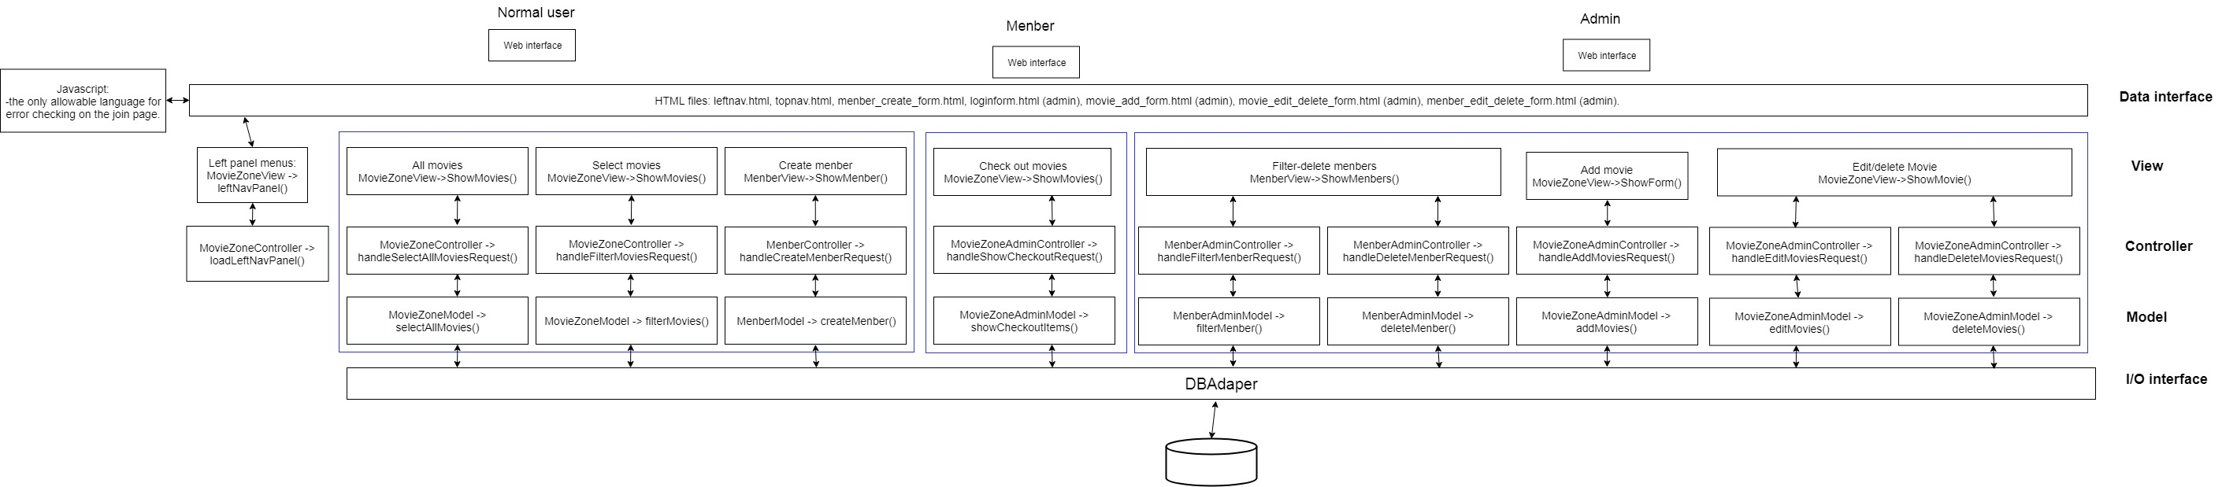
The high-level design diagram

Figure 1 high-level design diagram

The high-level design description
There are three types of visitors including administrator, member, normal User. They visit the site represent three different levels of permissions. User and administrator logging into the website will need to enter the request in the input/output interface component. The user’s request will be handled by JavaScript function and post request to the controller component. The controller examines the service required for the request and then invokes one or more components of model and view to provide the service. The model are allowed to handle the database adapter compomponent to operate database system. In database adapter, functions of connection, retrieves and insert data will satisfy the request. As a result, the result data will be package as an object and post to the controller. The view class will get the result date from controller and format them in html page in a user-friendly way.

Low-level design

Information about modules:
Module 1: Show movies model - selectAllMovies()
- POST_Input OUTPUT
- GET_Input

Movie detail output Module:
- movie_ID: int(10)
- title: String(45)
- tagline: String(128)
- plot: String(256)
- thumb_Path: String(40)
- star1: String(128)
- star2: String(128)
- star3: String(128)
- costar1: String(128)
- costar2: String(128)
- costar3: String(128)
- director: String(128)
- studio String(128)
- genre: String(128)
- classification: String(128)
- rental_period: String(128)
- year: int(4)
- DVD_retal_price: float
- DVD_purchase_price: float
- numDVD: int(3)
- numDVDout: int(3)
- BluRay_rental_price: float
- BluRay_purchase_price: floar
- numBluRay: int(3)
- numBluRayOut: int(3)
- selectAllMovies() INPUT

Module 2: Filter movie by criteria model - filterMovies()
- POST_Input OUTPUT
- GET_Input

MovieZoneModule:
- movie_ID: int(10)
- title: String(45)
- tagline: String(128)
- plot: String(256)
- thumb_Path: String(40)
- star1: String(128)
- star2: String(128)
- star3: String(128)
- costar1: String(128)
- costar2: String(128)
- costar3: String(128)
- director: String(128)
- studio String(128)
- genre: String(128)
- classification: String(128)
- rental_period: String(128)
- year: int(4)
- DVD_retal_price: float
- DVD_purchase_price: float
- numDVD: int(3)
- numDVDout: int(3)
- BluRay_rental_price: float
- BluRay_purchase_price: floar
- numBluRay: int(3)
- numBluRayOut: int(3)
- filterMovies() INPUT

Module 3: Add a movie model - addMovie()
- POST_Input INPUT
- GET_Input

MovieZoneAdminModule:
- movie_ID: int(10)
- title: String(45)
- tagline: String(128)
- plot: String(256)
- thumb_Path: String(40)
- star1: String(128)
- star2: String(128)
- star3: String(128)
- costar1: String(128)
- costar2: String(128)
- costar3: String(128)
- director: String(128)
- studio String(128)
- genre: String(128)
- classification: String(128)
- rental_period: String(128)
- year: int(4)
- DVD_retal_price: float
- DVD_purchase_price: float
- numDVD: int(3)
- numDVDout: int(3)
- BluRay_rental_price: float
- BluRay_purchase_price: floar
- numBluRay: int(3)
- numBluRayOut: int(3)
- addMovies() OUTPUT
Save to database

Module 4: Edit movie detail model - editMovies()
- POST_Input INPUT
- GET_Input

MovieZoneAdminModule:
- movie_ID: int(10)
- title: String(45)
- tagline: String(128)
- plot: String(256)
- thumb_Path: String(40)
- star1: String(128)
- star2: String(128)
- star3: String(128)
- costar1: String(128)
- costar2: String(128)
- costar3: String(128)
- director: String(128)
- studio String(128)
- genre: String(128)
- classification: String(128)
- rental_period: String(128)
- year: int(4)
- DVD_retal_price: float
- DVD_purchase_price: float
- numDVD: int(3)
- numDVDout: int(3)
- BluRay_rental_price: float
- BluRay_purchase_price: floar
- numBluRay: int(3)
- numBluRayOut: int(3)
- editMovies() OUTPUT
Save to database

Module 5: Delete movie model - deleteMovies()
- POST_Input INPUT
- GET_Input

MovieZoneAdminModule:
- movie_ID: int(10)
- deleteMovies() OUTPUT

Module 6: Create member model- createMember() //Admin function
- POST_Input INPUT
- GET_Input

MenberModule:
- menber_ID: int(10)
- surname: String(128)
- other_name: String(128)
- contact_method: String(10)
- email: String(40)
- mobile: String(40)
- landline: String(40)
- magazine: int(1)
- street: String(40)
- suburb: String(40)
- postcode: int(4)
- username: String(10)
- password: String(10)
- occupation: String(20)
- join_date: date
- createMenber() OUTPUT
SaveToDatabase

Module 7: Edit member model - editMember() //Admin function
- POST_Input INPUT
- GET_Input

MenberModule:
- menber_ID: int(10)
- surname: String(128)
- other_name: String(128)
- contact_method: String(10)
- email: String(40)
- mobile: String(40)
- landline: String(40)
- magazine: int(1)
- street: String(40)
- suburb: String(40)
- postcode: int(4)
- username: String(10)
- password: String(10)
- occupation: String(20)
- join_date: date
- updateMenber() OUTPUT
SaveToDatabase
Module 8: Delete member model - deleteMember() //Admin function
- POST_Input INPUT
- GET_Input

MenberModule:
- menber_ID: int(10)
- deleteMenber() OUTPUT
Delete a member from Database

Module 9: check out movies DVD model - checkoutItems() //user function
- POST_Input OUTPUT
- GET_Input

MovieZoneAdminModule:
- movie_ID: int(10)
- title: String(45)
- tagline: String(128)
- year: int(4)
- numDVD: int(3)
- showCheckoutItems() INPUT
Output the checkout items to webpages

Information about controller
Controller 1: MovieZoneController - loadLeftNavPanel()
User accesses web page INPUT

Call leftNavpanel() method in View class

leftNavPanel( ) OUTPUT

Controller 2: MovieZoneController - loadTopNavPanel()
User accesses web page INPUT

Call topNavpanel() method in View class

topNavPanel( ) OUTPUT

If the result of actors, directors, genres, classification from model class are existed, the method will show the result in list through view class.

Controller 3: MovieZoneController - handleSelectAllMovieRequest( )
POST_Input INPUT
GET_Input

Call selectAllMovies() in Model
IF the result of movie is not null THEN
showMovies( )
ELSE
showError( )

handleSelectAllMovieRequest() OUTPUT

If the result of movie detail is existed, the method will show the result in list through view class. Otherwise, the class will show the error message.

Controller 3: MovieZoneController - handleFilterMovieRequest( )
REQUEST_Input INPUT

IF input not empty
Assign criteria id of corresponding type to variable
Call filterMovies() in the Model
IF movies not empty
Call showMovies( ) in View
ELSE
Call showError( ) in View

showMovies( ) OUTPUT

Controller 4: MovieZoneController - handleAddMovieRequest( )//for admin
REQUEST_Input INPUT

Create an array that contains data of a movie : keys[]
Create a null array to contain keys[]: moviedata[]
FOREACH data attribute in keys[]
IF the keys[] array not null
Assign keys to moviedata[ ]
ELSE
Call showError( )
Call addMovie( ) in Model
IF output null
Call getError( ) in Model
IF error not empty
Call showError( ) in View

Save to the database OUTPUT

Controller 5: MovieZoneController - handleEditMovieRequest( )//for admin

REQUEST_Input INPUT

Create an array that contains data of a movie : keys[]
Create a null array to contain keys[]: moviedata[]
FOREACH data attribute in keys[]
IF the keys[] array not null
Assign keys to moviedata[ ]
ELSE
Call showError( )
Call addMovie( ) in Model
IF output null
Call getError( ) in Model
IF error not empty
Call showError( ) in View

- SaveToLocalDatabase
- SaveToInfoTechServer OUTPUT

Controller 6: MovieZoneController - handleDeleteMovieRequest( )

POST_Input
GET_Input INPUT

Create an array that contains data of a movie : keys[]
Create a null array to contain keys[]: moviedata[]
FOREACH data attribute in keys[]
IF the keys[] array not null
Assign keys to moviedata[ ]
ELSE
Call showError( )
Call deleteMovie( ) in Model
IF output null
Call getError( ) in Model
IF error not empty
Call showError( ) in View

- SaveToLocalDatabase
- SaveToInfoTechServer OUTPUT

Controller 7: MovieZoneController - handleCreateMemberRequest( )

POST_Input
GET_Input INPUT

Create an array that contains data of a member: keys[]
Create a null array to contain keys[]: memberdata[]
FOREACH data attribute in keys[]
IF the keys[] array not null
Assign keys to memberdata[ ]
ELSE
Call showError( )
Call createMember( ) in Model
IF output null
Call getError( ) in Model
IF error not empty
Call showError( ) in View

- SaveToLocalDatabase
- SaveToInfoTechServer OUTPUT

Controller 8: MovieZoneController - handleEditMemberRequest( )

POST_Input
GET_Input INPUT

Create an array that contains data of a member: keys[]
Create a null array to contain keys[]: memberdata[]
FOREACH data attribute in keys[]
IF the keys[] array not null
Assign keys to memberdata[ ]
ELSE
Call showError( )
Call editMember( ) in Model
IF output null
Call getError( ) in Model
IF error not empty
Call showError( ) in View

- SaveToLocalDatabase
- SaveToInfoTechServer OUTPUT

Controller 9: MovieZoneController - handleDeleteMemberRequest( )

POST_Input
GET_Input INPUT

Create an array that contains data of a member: keys[]
Create a null array to contain keys[]: memberdata[]
FOREACH data attribute in keys[]
IF the keys[] array not null
Assign keys to memberdata[ ]
ELSE
Call showError( )
Call deleteMember( ) in Model
IF output null
Call getError( ) in Model
IF error not empty
Call showError( ) in View

- SaveToLocalDatabase
- SaveToInfoTechServer OUTPUT

Controller 10: MovieZoneController - handleCheckoutRequest( )

REQUEST_Input INPUT

Create an array for selected movies: selected_movies
Or retrieve it from session storage
Get movie id by REQUEST method
Convert selected_movies to string
IF selected_movies not empty
Set movie id into array selected_movies and assign it the value of 1
ELSE
Unselect the movie by removing the id
Save to SESSION for next time access
showMovies( ) OUTPUT

Information about view
Module 1: View - leftNavPanel( )

POST_Input
GET_Input INPUT

Print leftnav html file
showMovies( ) OUTPUT

Module 2: View - showMovies( )
POST_Input
GET_Input INPUT

IF an array of movies not empty
printMovieHtml(movie)

showMovies( ) OUTPUT

Module 3: View - showError( )
POST_Input
GET_Input INPUT

Print Error:

showMovies( ) OUTPUT

The low-level design description
The movie zone website includes three components: controller, view and model. The view component display all of data in need to the interface. JavaScript will get the request and parameters from interface then post to controller component. The controller based on the user request invokes the appropriate functionality from the model class, which consist of a variety of method to provide different functionality. And model handles adapter class which is allowed to operate the database system. The controller component can request to create different view. The general working flows are as follows.
- User send a request using browser to the server
- JavaScript post the request and parameters to controller
- The controller reads the request and parameters
- The controller detects the request command
- The controller request services of the model class function to services the client request by invoking the function with appropriate parameters
- The model class deal with the database adapter classes to retrieve the needed data and sends it back to the controller
- The controller class passed the retrieve data or error if no data available to the view class function
- The view class formats the data and display the results to the end user.

User case description
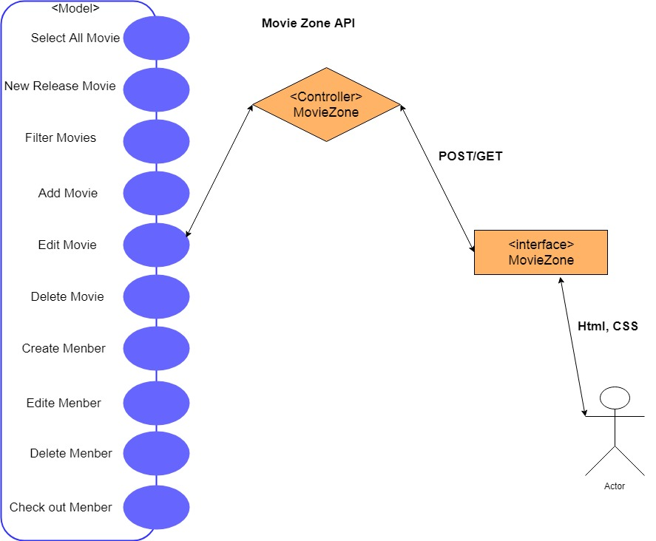

Figure 2 Use Case Diagram

As above, the use case diagram in figure 2 describes all of requirements of movie zone website, including searching particular movies by different movie detail, edit movie detail, initiating member accessing the website. And then, member can check out the movies they selected. For instance, in the actor filter, users are allowed to select any actors in the list and get the result in need. In output processing, data retrieval are managed by the controller, model and view components.

The link of my assignment1 is: http://infotech.scu.edu.au/~jtang13/assignment1

